

**FUNDAMENTAL OF PROGRAMMING**

***LAB MANUAL 6***

**LAB TASKS**

**NAME :** Daniyal Ahmed

**CLASS :** ME-15

**SECTION :** B

**CMS ID :** 457165

**DATE:14/11/2023**

**TASK 1**

#include <iostream>

using namespace std;

int main(){

int a,c,b,sum;

cout<<"Enter first digit of the fibonacci sequence : ";

cin>>c;

cout<<"Enter second digit of the fibonacci sequence : ";

cin>>b;

cout<<"Enter how many times do the fibonacci sequence occur : ";

cin>>a;

cout<<c;

for(int i=1;i<=a-1;++i){

for(int j=i;j<=i;++j){

sum=c+b;

b=c;

c=sum;

cout<<"\t"<<sum;

}

}

return 0;

}

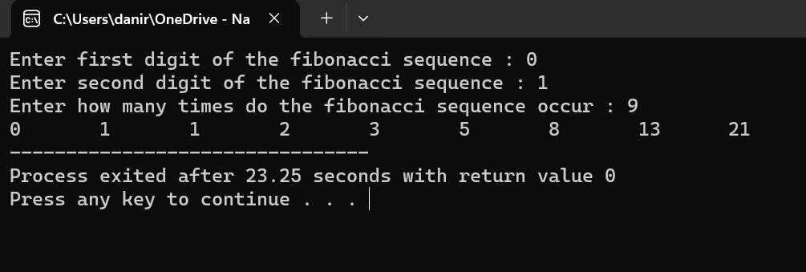

**TASK 2**

#include <iostream>

using namespace std;

int main()

{

int rows,a=1;

cout<<"Enter number of rows for Floyd's triangle : ";

cin>>rows;

for(int i=1;i<=rows;++i){

for(int j=1;j<=i;++j){

cout<<a<<" ";

++a;

}

cout<<endl;

}

return 0;

}

